STEP 1: VPN Connection
ProtonVPN successfully connected to a remote server
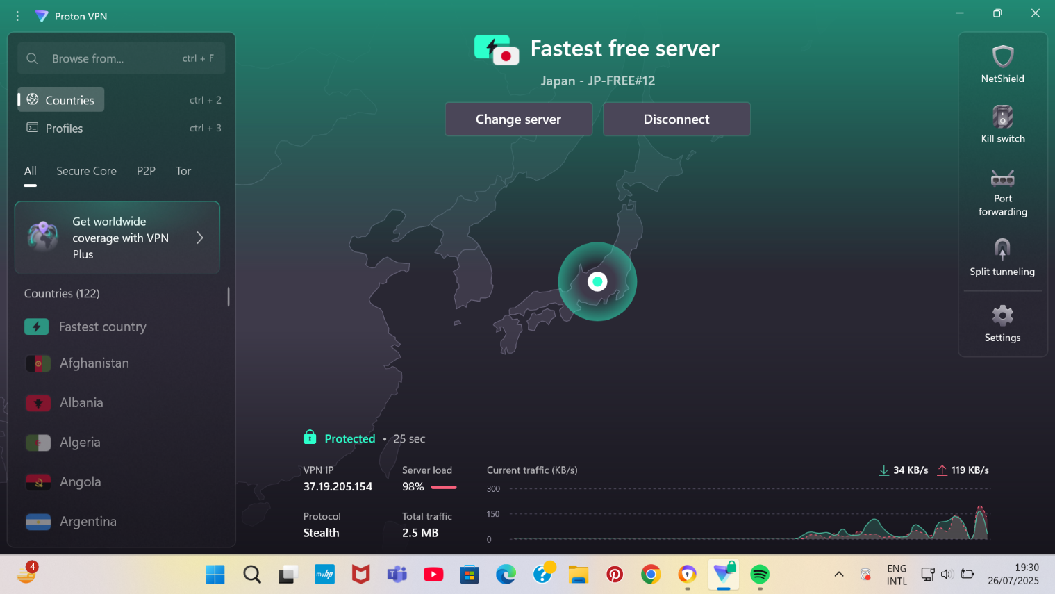

STEP 2: Wireshark Packet Capture (ProtonVPN)
Captured general network traffic after connecting the VPN
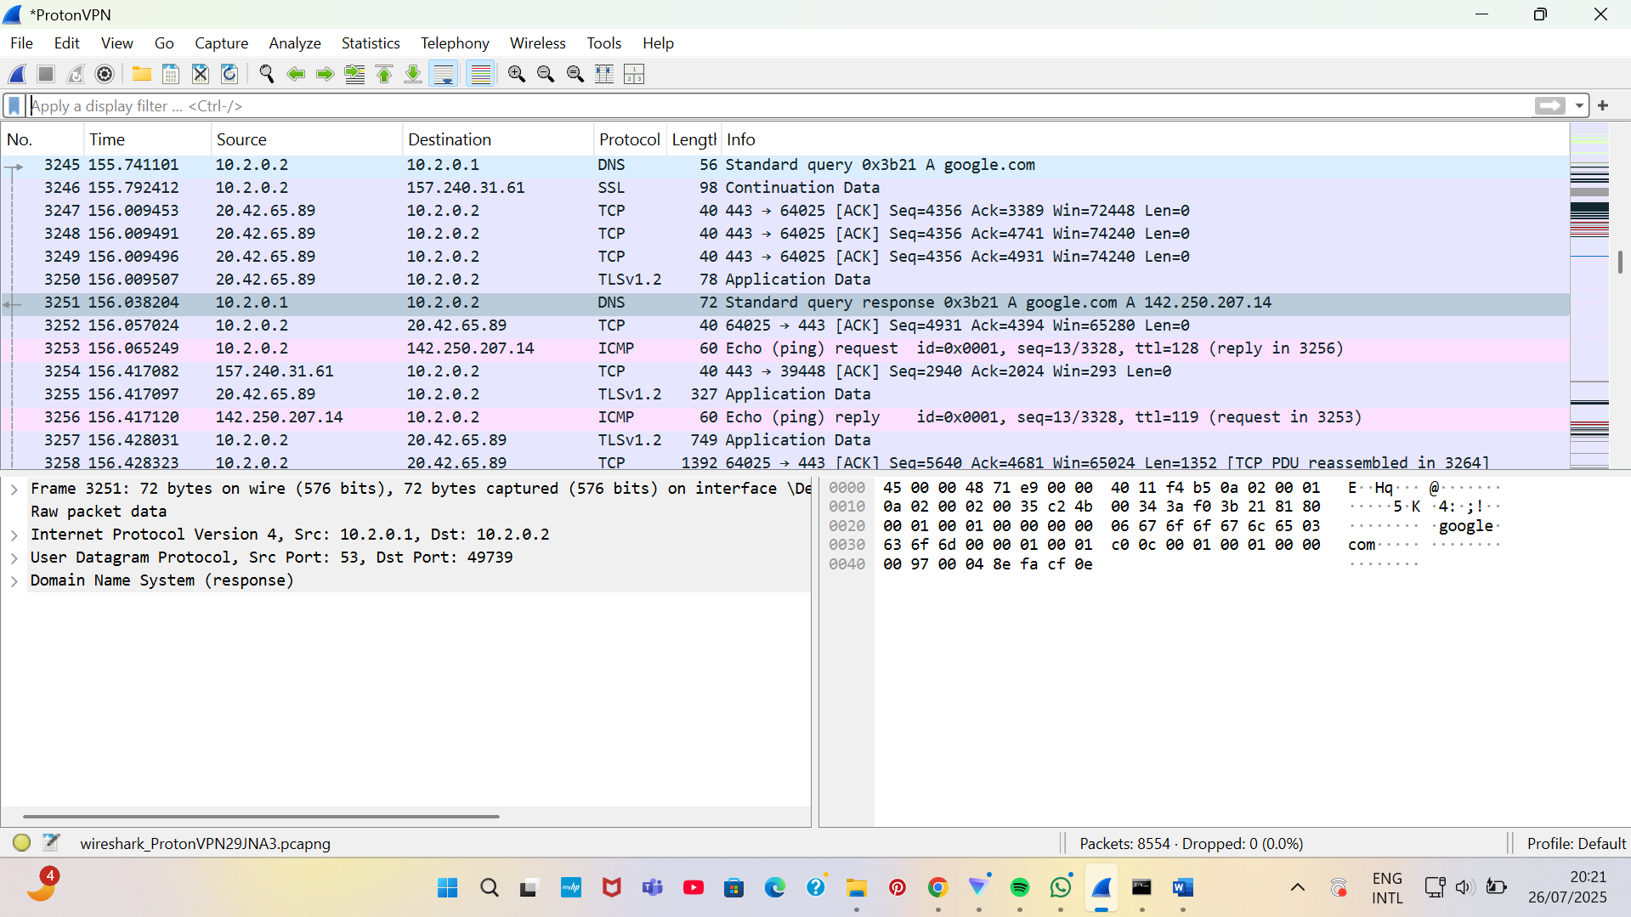
STEP 3: Ping Test
pinged google.com to general ICMP packets using command prompt
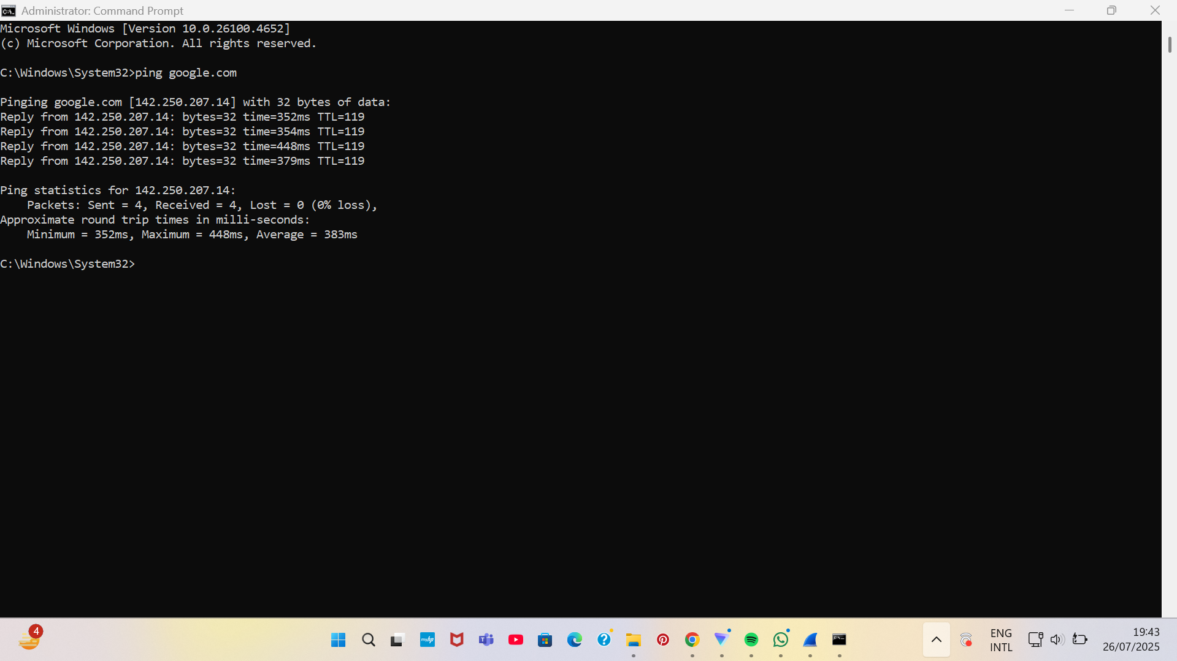

Filtered Packets
Filter: ICMP
Filtered ICMP packets from the ping test.
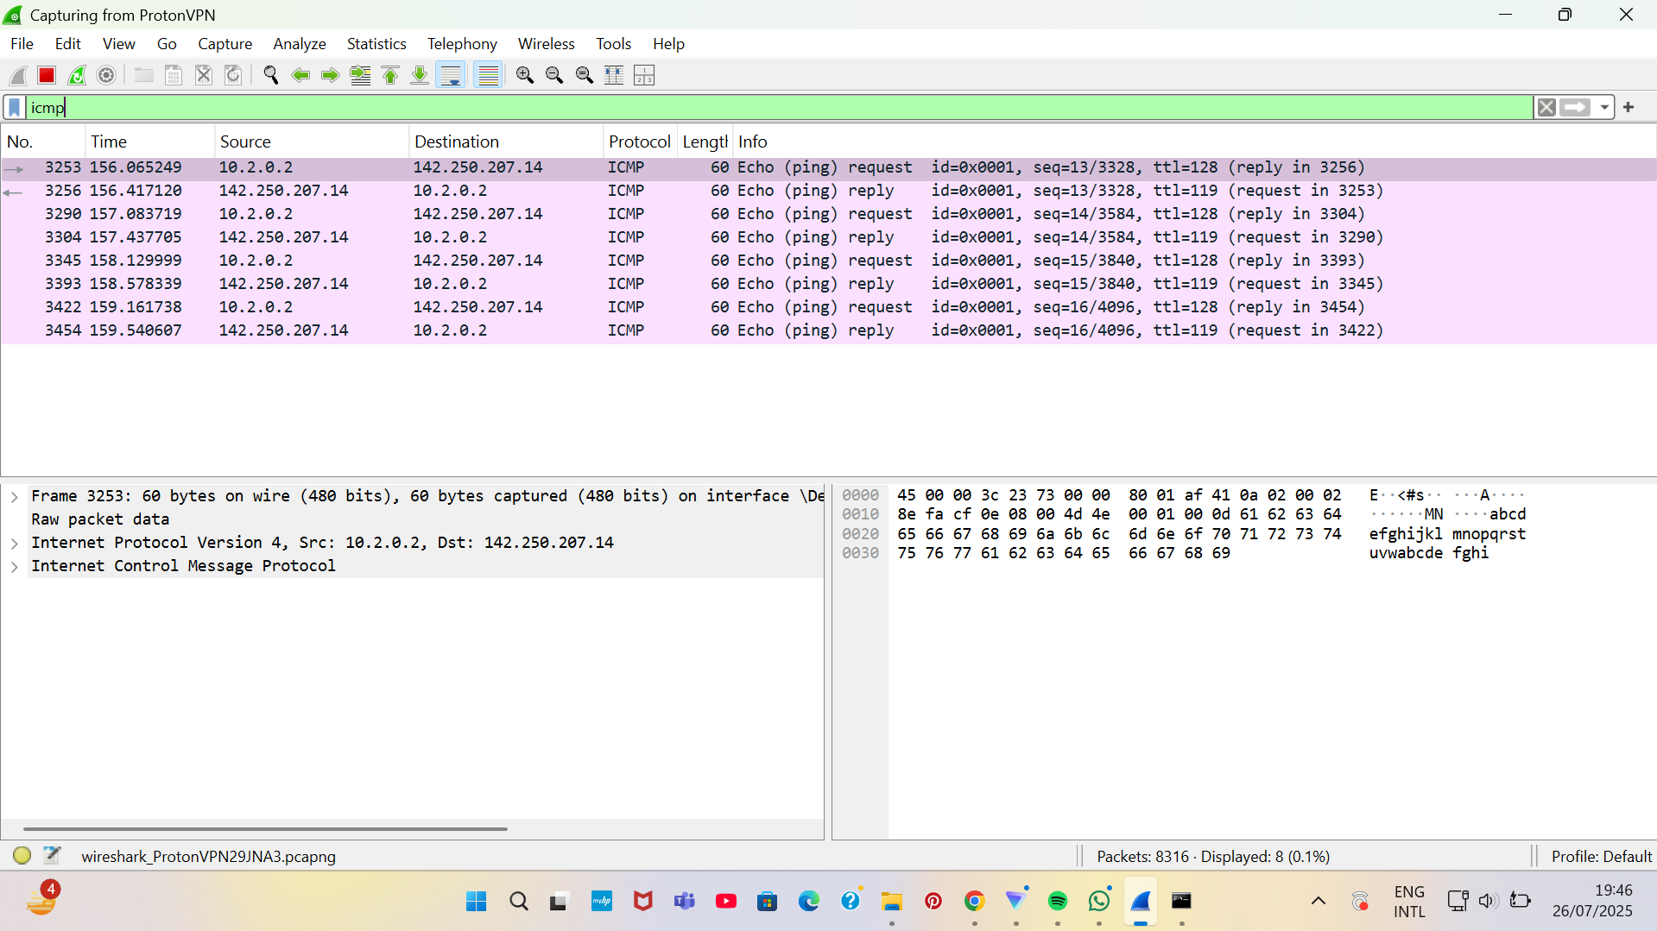
Filter: UDP
Shows UDP packets used by the VPN.
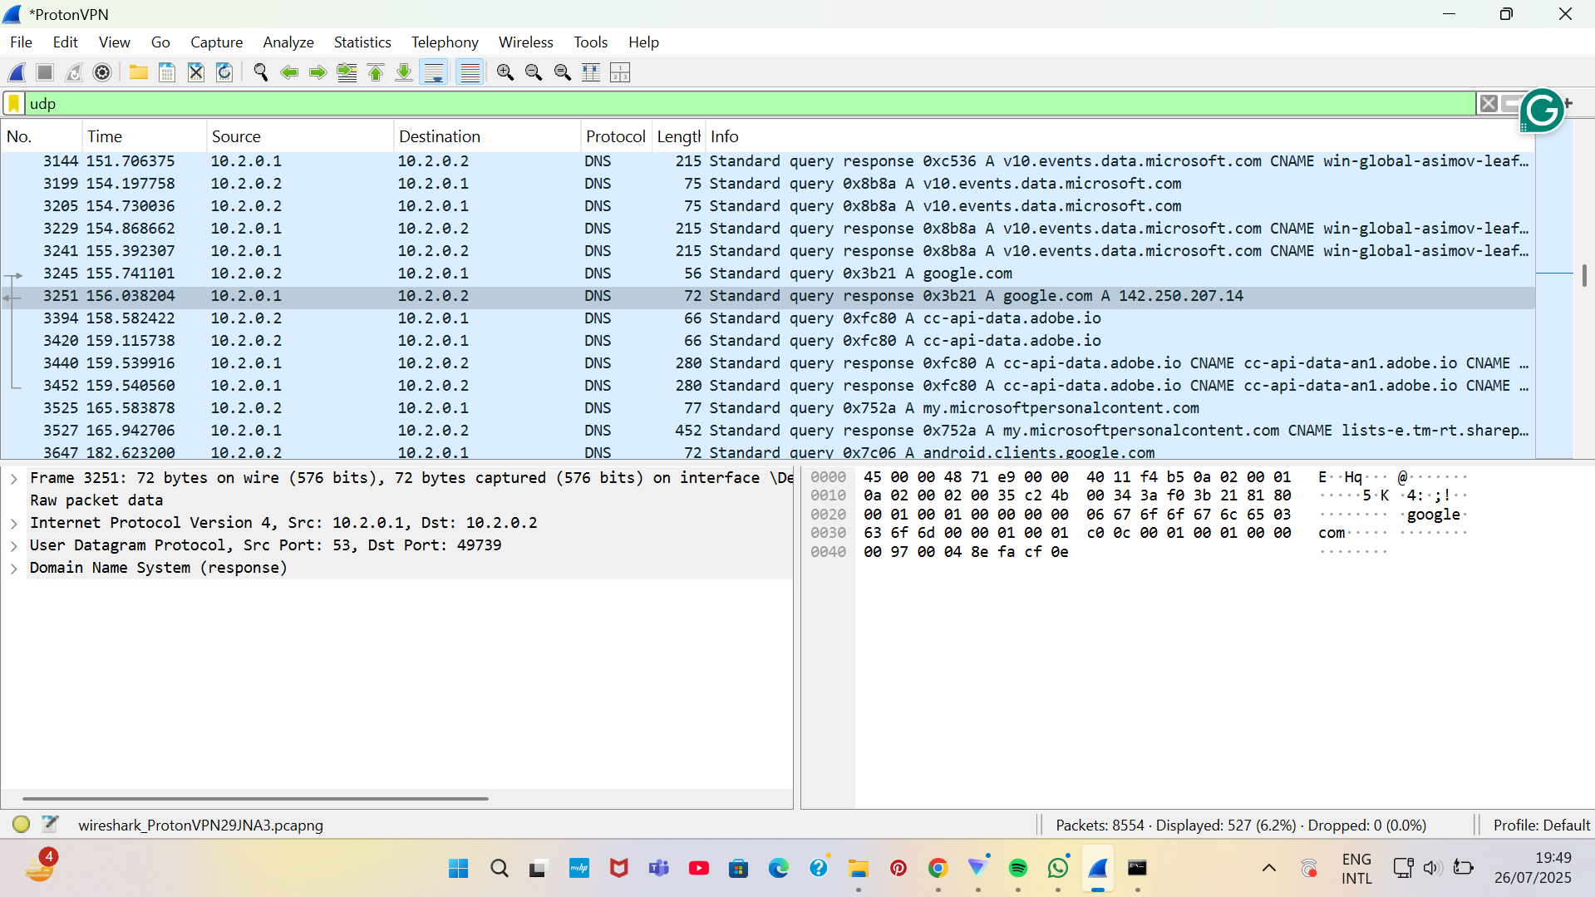

Filter: TCP
Shows background TCP traffic during the session.
